**Year 5 Homework - Friday 6th Dec 2024**



**Designing a New Sleigh for Father Christmas**

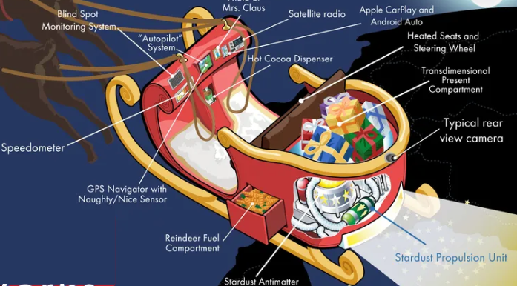

It’s time for some Christmas homework! Can you redesign Father Christmas’s sleigh to make it as effective as possible. Use some ideas from above or your own. Please label the design to show what you’ve included.

**Homework due in – Friday 13th Dec 24**